Assignment 2

1. **(Computer Center Staffing)** You are the Director of the Computer Center for Gaillard College and responsible for scheduling the staffing of the center. It is open from 8 am until midnight. You have monitored the usage of the center at various times of the day and determined that the following numbers of computer consultants are required.

|  |  |
| --- | --- |
| Time of day | Minimum number of consultants required to be on duty |
| 8 am–noon | 4 |
| Noon–4 pm | 8 |
| 4 am–8 pm | 10 |
| 8 am–midnight | 6 |

Two types of computer consultants can be hired: full-time and part-time. The full-time consultants work for eight consecutive hours in any of the following shifts: morning (8 am – 4 pm), afternoon (noon – 8 pm), and evening (4 pm – midnight). Full-time consult- ants are paid

$14 per hour.

Part-time consultants can be hired to work any of the four shifts listed in the table. Part-time consultants are paid $12 per hour. An additional requirement is that during every time period, at least one full-time consultant must be on duty for every part-time consultant on duty.

1. Determine a minimum-cost staffing plan for the center. In your solution, how many consultants will be paid to work full time and how many will be paid to work part time? What is the minimum cost?

Given:

Two types of consultants – Full time, Part-time

Number of hours for full time worker = 8 hours/shift

Number of hours for part-time worker = 4 hours/shift

Full time wages = $14/hour

Part-time wages = $12/hour

Decision Variable:

Let,

Xij, where i consultant in j shift

i =1 represents Full time consultant,

i =2 represents Part time consultant,

j represents Shift timings(morning(1), afternoon(2), evening(3), night(4))

X11 = Number of full-time consultants working on (8 am – 4 pm) Morning shift

X12 = Number of full-time consultants working on (noon – 8 pm) Afternoon shift

X13 = Number of full-time consultants working on (4 pm – midnight) Evening shift

X21 = Number of Part-time consultants working on (8 am – noon) Morning shift

X22 = Number of Part-time consultants working on (noon – 4 pm) Afternoon shift

X23 = Number of Part-time consultants working on (4 pm – 8 pm) Evening shift

X24 = Number of Part-time consultants working on (8 pm – midnight) Night shift.

Objective Function:

Minimum Cost Function(z) = (14 * 8) (X11 + X12 + X13) + (12 * 4) (X21 + X22 + X23 + X24)

Mathematical Formulation of Linear Programming Problem:

X11 + X21 >= 4,

X11 + X12 + X22 >= 8

X12 + X13 + X23 >= 10,

X13 + X24 >= 6

Constraints:

X1j>=X2j

X21, X12, X13 >= 0

X21, X22, X23, X24 >= 0

To find minimum cost:

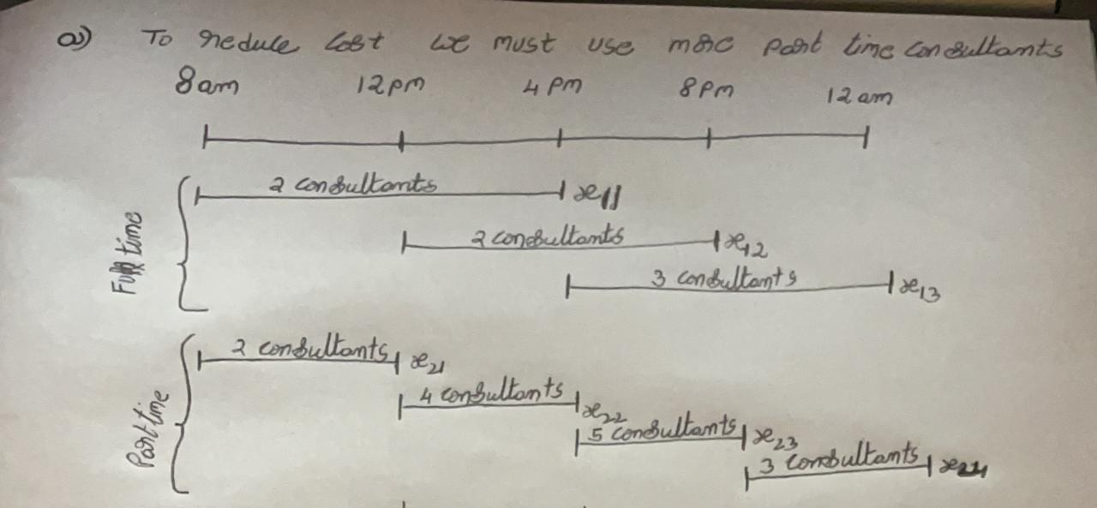

Minimum cost function(Z) = (14*8) (2+2+3) + (12*4) (2+4+5+3)

Z = 1456$

1. After thinking about this problem for a while, you have decided to recognize meal breaks explicitly in the scheduling of full-time consultants. In particular, full-time consultants are entitled to a one-hour lunch break during their eight-hour shift. In addition, employment rules specify that the lunch break can start after three hours of work or after four hours of work, but those are the only alternatives. Part-time consultants do not receive a meal break. Under these conditions, find a minimum-cost staffing plan. What is the minimum cost?

Hint: for this problem, you only need to formulate the LP problem without solving it.

We have to consider 1Hr meal break for the Full time consultants, so we have to deduct 1Hr from above objective function from Full time consultants. There is no meal break for Part time consultants

Objective Function:

Minimum Cost Function(z) = (14 * 7) (X11 + X12 + X13) + (12 * 4) (X21 + X22 + X23 + X24)

Mathematical Formulation of Linear Programming Problem:

X11 + Y21 >= 4,

X11 + X12 + X22 >= 8

X12 + X13 + X23 >= 10,

X13 + X24 >= 6

Constraints:

X1j>=X2j

X21, X12, X13 >= 0

X21, X22, X23, X24 >= 0

**2.** Back Savers is a company that produces backpacks primarily for students. They are considering offering some combination of two different models—the Collegiate and the Mini. Both are made out of the same rip-resistant nylon fabric. Back Savers has a long-term contract with a supplier of the nylon and receives a 5000 square-foot shipment of the material each week. Each Collegiate requires 3 square feet while each Mini requires 2 square feet.

The sales forecasts indicate that at most 1000 Collegiates and 1200 Minis can be sold per week. Each Collegiate requires 45 minutes of labor to produce and generates a unit profit of

$32. Each Mini requires 40 minutes of labor and generates a unit profit of $24. Back Savers has 35 laborers that each provides 40 hours of labor per week. Management wishes to know what quantity of each type of backpack to produce per week. Solve this problem graphically.

Total Nylon sheet in square-foot- 5000

Total working time in minutes-84000

a. Decision Variables - Collegiate(X1) & Mini(X2)

b. Objective function for profit maximization (Z) = 32X1+24X2

c. Constraints- X1>=1000

X2>=1200

d. Mathematical formulation- 3X1+2X2<=5000

45X1+40X2<=84000

X1,X2>=0

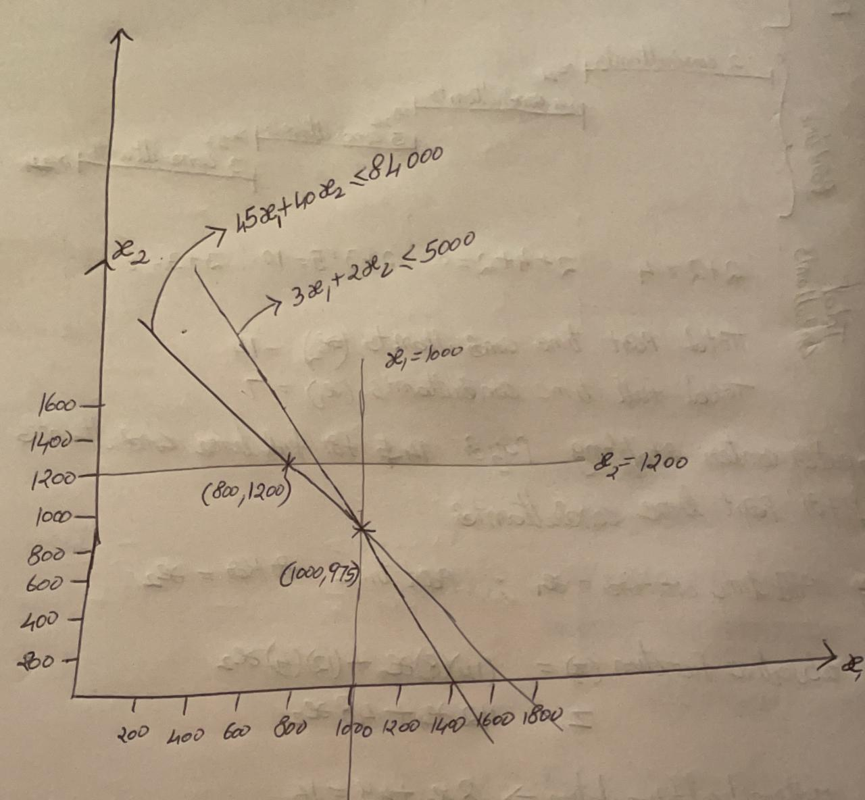

The optimal solution for the problem is, Bank Savers Company should produce 1000 units of collegiate bags and 975 units of Mini Bags to earn maximum profit

1. **(Weigelt Production)** The Weigelt Corporation has three branch plants with excess production capacity. Fortunately, the corporation has a new product ready to begin production, and all three plants have this capability, so some of the excess capacity can be used in this way. This product can be made in three sizes--large, medium, and small-- that yield a net unit profit of $420, $360, and $300, respectively. Plants 1, 2, and 3 have the excess capacity to produce 750, 900, and 450 units per day of this product, respectively, regardless of the size or combination of sizes involved.

The amount of available in-process storage space also imposes a limitation on the production rates of the new product. Plants 1, 2, and 3 have 13,000, 12,000, and 5,000 square feet, respectively, of in-process storage space available for a day's production of this product. Each unit of the large, medium, and small sizes produced per day requires 20, 15, and 12 square feet, respectively.

Sales forecasts indicate that if available, 900, 1,200, and 750 units of the large, medium, and small sizes, respectively, would be sold per day.

At each plant, some employees will need to be laid off unless most of the plant’s excess production capacity can be used to produce the new product. To avoid layoffs if possible, management has decided that the plants should use the same percentage of their excess capacity to produce the new product.

Management wishes to know how much of each of the sizes should be produced by each of the plants to maximize profit.

* 1. Define the decision variables
  2. Formulate a linear programming model for this problem.
  3. Solve the problem using *lpsolve*, or any other equivalent library in R.

1. Decision Variable:

Let,

Xij = Quantity of each sizes i of products produced by each plant j in Weigelt Corporation.

i = Sizes of products(Large, Medium, Small),

i = L, M, S

j = Plants in which the products are produced.

j = 1, 2, 3

Objective function:

Maximum profit function(Z) = 420 (XL1 + XL2 + XL3) + 360 (XM1 + XM2 + XM3) +

300 (XS1 + XS2 + XS3)

1. Mathematical Formulation of Linear Programming Problem:

900(XL1 + XM1 + XS1) = 750(XL2 + XM2 + XS2)

450(XL2 + XM2 + XS2) = 900(XL3 + XM3 + XS3)

750(XL3 + XM3 + XS3) = 450(XL1 + XM1 + XS1)

900(XL1 + XM1 + XS1) - 750(XL2 + XM2 + XS2) = 0

450(XL2 + XM2 + XS2) - 900(XL3 + XM3 + XS3) = 0

750(XL3 + XM3 + XS3) - 450(XL1 + XM1 + XS1) = 0

Constraints:

Capacity

XL1 + XM1 + XS1 <= 750 units

XL2 + XM2 + XS2 <= 900 units

XL3 + XM3 + XS3 <= 450 units

Storage Space

20XL1 + 15 XM1 + 12 XS1 <= 13,000 sq. ft.

20XL2 + 15 XM2 + 12 XS2 <= 12,000 sq. ft.

20XL3 + 15 XM3 + 12 XS3 <= 5,000 sq. ft.

Sales forecast

XL1 +XL2 + XL3 <= 900 units

XM1 + XM2 + XM3 <= 1200 units

XS1 + XS2 + XS3 <= 750 units

**3c** is in R format